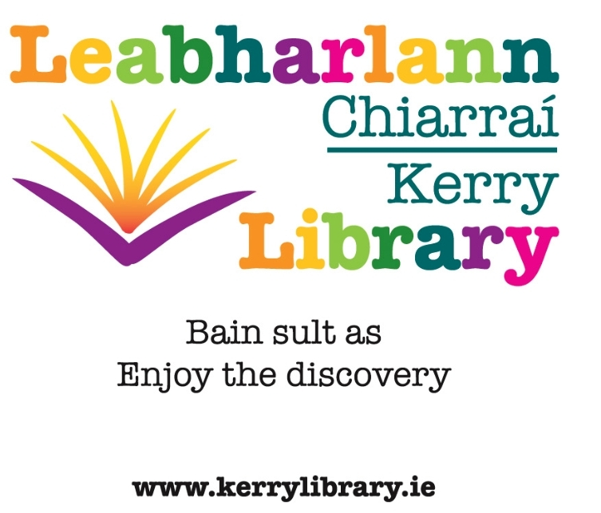

Kerry Library: Decade of Commemoration Programme

Events 2013 - 2022

Lectures / Exhibitions

2020

21 April: Killarney Library, 7.30p.m.
Lecture:
A Century of Service – a history of the Irish Nurses and Midwives Organisation 1919 - 2019
by Dr. Marc Loughrey, Historian & Nurse
[in association with the Kerry Archaeological & Historical Society]

July & August: Leabharlann Dhaingean Uí Chúis
Exhibition
Tomás Ághas Exhibition & Display

2019

26 February: Killarney Library
Lecture:
The Catholic Church and the War of Independence
by Greg Daly, Irish Catholic Journalist & author
[in association with the Kerry Archaeological & Historical Society]

12 November: Tralee Library
Lecture:
The ‘Kerryman’ and the Revolution
by Gordon Revington, member & journalist
[in association with the Kerry Archaeological & Historical Society]

8 Dec. 2018 – 26 Jan. 2019: Tralee Library
Exhibition
Exhibition commemorating the Kerry members of the First Dáil

Travelling Exhibitions at various Kerry Libraries throughout 2019:
- Tomás Ághas
- The First Dáil: Kerry members

2018

26 March – 6 April: Leabharlann Dhaingean Uí Chúis
Exhibition
Thomas Russell Centenary Exhibition

22 November: Tralee Library
Lecture:
The General Election of 1918 and the First Dáil
by Daithí Ó Corráin, member and author
[in association with the Kerry Archaeological & Historical Society]

2017

10 July – 14 October: Leabharlann Dhaingean Uí Chúis
Exhibition
Tomás Ághas Centenary Display

7 September 2017: Tralee Library, 7.30p.m.
Lecture:
Thomas Ashe: a life
by Maurice O’Keeffe, historian.

3 – 31 March: Tralee Library
Exhibition
Case Studies of the 1916 Rising

3 – 28 February: Killarney Library
Exhibition
Case Studies of the 1916 Rising: exhibition highlighting the major events of that week with the case studies on some of the individuals involved in various aspects of the events before, during and after the Rising. The case studies give a little biography of people involved on many levels, from senior IRB members and Volunteer Officers, to nurses serving under artillery fire, and teenage members of the Irish Citizen Army.

28 February 2017: Tralee Library, 7.30p.m.
Lecture:
Seán Keating and the fine art of nation building
by Dr. Eimear O’Connor, Art Historian & author, T.C.D.
[in association with the Kerry Archaeological & Historical Society]

2016

8 November 2016: Tralee Library, 7.30p.m.
Lecture:
Firies 1916 and volunteers’ actions
by Tim Horgan, author.
[in association with the Kerry Archaeological & Historical Society]

5 – 17 September: Tralee Library
Exhibition
Memorials & memorabilia on Roger Casement

12 September 2016: Killarney Library, 7.30p.m.
Lecture:
Frongoch Camp, Wales and Kerry P.O.W’s
by Rev. Tom Looney, author.
[in association with the Kerry Archaeological & Historical Society]

Exhibition
22 March – 30 April: Tralee Library
‘1916 from the archives’ – a display of material from the holdings of Kerry Library relating to the events of 1916

15 March 2016: Killarney Library, 7.30p.m.
Lecture:
The Royal Munster Fusiliers and Gallipoli WW1
by Thomas F. Martin, historian and author.
[in association with the Kerry Archaeological & Historical Society]

8 March 2016: Tralee Library, 7.30p.m.
Lecture:
Austin Stack
by Rev. J Anthony Gaughan, historian

1 March 2016: Killarney Library, 7.30p.m.
Lecture:
The Irish Volunteers
by Daithí Ó Corráin, author.
[in association with the Kerry Archaeological & Historical Society]

18 February: Tralee Library, 7.30p.m.
Lecture:
The role of Kerry women in 1916 [title to be confirmed]
by Dr. Mary McAuliffe

9 February, Tralee Library, 7.30p.m.
Lecture:
The Asgard – with arms for 1916
by Pat Murphy, Asgard volunteer & historian.
[in association with the Kerry Archaeological & Historical Society]

Libraries and Post Primary Schools 1916 Poetry Competition

This competition is a partnership between the Dept. of Education & Skills, the Local Authority Library Services and Libraries Development, Local Government Management Agency [LGMA].
It is targeted at post primary schools and invites post primary students to submit a poem on the wide-ranging topic ‘Your Ireland’. There will be county competitions and a national final.
The county competitions will be launched in January 2016 and promoted by the schools and the libraries. The closing date for entries will be Monday the 29th of February 2016.
Poems will be submitted at class level in the school, adjudicated on at class level and class winners will be sent from the school to the local library branch. A judging panel set up by the local library service will adjudicate on all schools’ class winner entries in March and will award a county winner at an event.
County winners will be reviewed by a national panel of judges set up by Libraries Development, LGMA and short listed to eight national finalists. The national final will be held in April 2016 and President Michael d. Higgins will be invited to present the prize to the overall winner.

[The Department of Education and Skills will be sending details to schools in September 2015]

2015

20 October: Tralee Library, 7.30p.m.
Lecture:
Ardfert witnesses at the trial of Sir Roger Casement
by Helen O’Carroll, Kerry County Museum
[in association with the Kerry Archaeological & Historical Society]

26 August: Local History & Archives Section, Kerry Library, 11.00a.m. & 3.00p.m.
Display:
A display of Kerry Library archives and memorabilia detailing what life was like in Kerry in 1915
Presentation: Kerry in 1915
by Michael Lynch, archivist, Kerry Library
[Heritage Week event]

10 February: Tralee Library, 7.30p.m.
Lecture:
The Men will talk to me
by Dr. Tim Horgan.
[in association with the Kerry Archaeological & Historical Society]

2014

6 December: Caherciveen Library, 3.00p.m.
Lecture:
Irish revolutionary, politician & judge, Caherciveen born Fionán Lynch – ‘Laying the foundation of the Irish State’
by Dr. Maurice Manning, Professor Tim Lynch and Minister Jimmy Deenihan.

18 November: Tralee Library, 7.30p.m.
Lecture:
Tomás Ághas – the patriot’s Dublin days
by Mícheál Ó Móráín.

4 November: Listowel Seanchaí Centre
Lecture:
The O’Rahilly
by Pádraig Ó Conchubhair
[in association with the Kerry Archaeological & Historical Society]

19 September [Culture Night]: Killarney Library, 7.30p.m.
Lecture:
World War 1 and Kerry.
by Noel Grimes, Local Historian

15 September – 27 September: Killarney Library
Exhibition
World War 1, commemorating the centenary with memorabilia and pictures

23 May – 27 May: Tralee Library
Exhibition
History of the Royal Munster Fusiliers & their Kerry connections.
15 May: Tralee Library, 7.30p.m.
Lecture:
Cumann na mBan in Kerry, 1914 - 1923
by Dr. Mary McAuliffe

Monday, 31 March – Monday, 14 April: Listowel Library
Exhibition
Irish historical letters and posters

2013

21 Oct. – 9 Nov.: Tralee Library
Exhibitions
Roger Casement Exhibitions
- The Global Empire
- Casement Memorials in North Kerry
Official opening Thursday, 24 October.

by Rev. Canon Tom Looney.

4 - 29 June: Caherciveen Library
Exhibition
Gallant sons: Irishmen and the First World War.

26 February: Killarney Library
Lecture
The founding of the Volunteers in Killarney, 1913.


